statement of requirement B1-K1-W1

# Information

Fischer Technik Automated High-Bay warehouse is a transfer station conveyer belt, shelf stacker for storing and retrieving boxes. It is controlled by a PLC (Programmable logic controller). the motherboard of the Automated High-Bay warehouse has a motherboard with relays for reversing the direction of the motors. It requires 24 Volts to operate.

# Information through communication

The Automated High-Bay warehouse will be controlled by a controllino mega which also has an ethernet connector for possible communication between a web application.

# Additional needed information

Storing and retrieving goods is done by rack feeders that move in a lane between two rows of racks. This area is part of the receiving station, where identification of goods also takes place. The goods arrive and are transferred to the rack feeder the goods are provided on a conveyor belt. The goods are identified by a colour code, which is read by the trail sensor. The pre-loading is the high-bay warehouse area where the goods are prepared and identified.

# Bijlage schema’s controllino mega & warehouse bay

<https://controllino.biz/wp-content/uploads/2017/03/MEGA_DATASHEET-19-04-20161.pdf>

Fisher technik

# MoSCoW(requirements)

|  |  |  |  |
| --- | --- | --- | --- |
| Must | Should | Could | Won’t |
| Moving arm | Check if boxes are empty | Website control | Break the components |
| Stock rescan(uses EEPROM) | Return Box | If no production organize racks | Cause any harm |
| HMI(Human machine interface)C# |  |  |  |
| Place on conveyer belt |  |  |  |
| Pick up from conveyer belt |  |  |  |
| Manual/Automatic stock checking |  |  |  |
| Testing Inputs/Outputs |  |  |  |

Name Client: Name Contractor:

Date: Date:

Signature Client: Signature Contractor:



**536631**

**Automated High****-Bay Warehouse 24V**

Q7/Q8

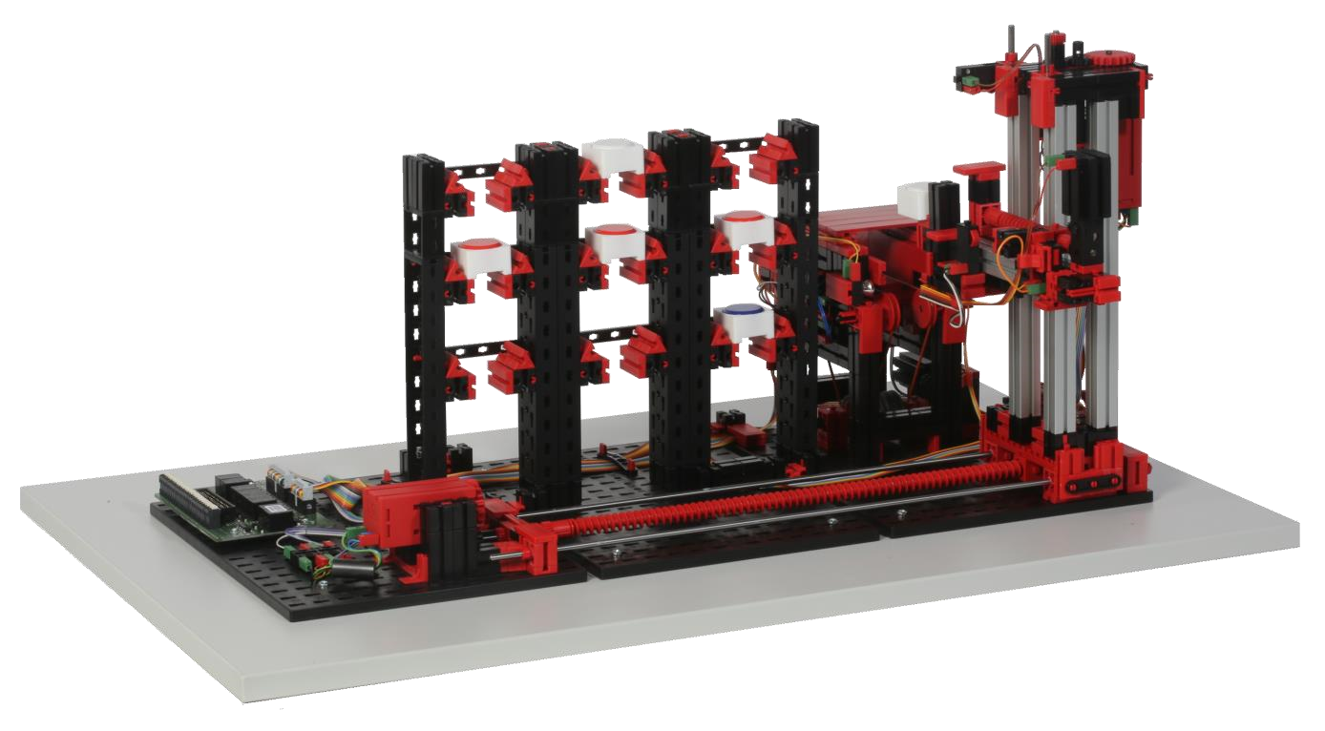

Q3/Q4 + B1/B2

Q5/Q6 + B3/B4

I2

I4

A1+A2

I5

I5

Q1/Q2

# Circuit layout of the Automated High-Bay Warehouse

|  |  |  |
| --- | --- | --- |
| **Terminal no.** | **Function** | **Input/Output** |
| 1 | power supply (+) actuators | 24V DC |
| 2 | power supply (+) sensors | 24V DC |
| 3 | power supply (-) | 0V |
| 4 | power supply (-) | 0V |
| 5 | reference switch horizontal axis | I1 |
| 6 | light-barrier inside | I2 |
| 7 | light-barrier outside | I3 |
| 8 | reference switch vertical axis | I4 |
| 9 | trail sensor (signal 1, lower) | A1 |
| 10 | trail sensor (signal 2, upper) | A2 |
| 11 | encoder horizontal axis impulse 1 | B1 |
| 12 | encoder horizontal axis impulse 2 | B2 |
| 13 | encoder vertical axis impulse 1 | B3 |
| 14 | encoder vertical axis impulse 2 | B4 |
| 15 | reference switch cantilever front | I5 |
| 16 | reference switch cantilever back | I6 |
| 17 | motor conveyor belt forward | Q1 (M1) |
| 18 | motor conveyor belt backward | Q2 (M1) |
| 19 | motor horizontal towards rack | Q3 (M2) |
| 20 | motor horizontal towards conveyor belt | Q4 (M2) |
| 21 | motor vertical axis downward | Q5 (M3) |
| 22 | motor vertical axis upward | Q6 (M3) |
| 23 | motor cantilever forward | Q7 (M4) |
| 24 | motor cantilever backward | Q8 (M4) |

+24V (actuators) 1 2 +24V (sensors)

0V (GND) 3 4 0V (GND)

I1 5 6 I2

I3 7 8 I4

A1 9 10 A2

B1 11 12 B2

B3 13 14 B4

I5 15 16 I6

Q1 17 18 Q2

Q3 19 20 Q4

Q5 21 22 Q6

Q7 23 24 Q8

25 26

27 28

29 30

31 32

GND 33 34 GND

# PLC input and output configuration

|  |  |  |
| --- | --- | --- |
|  | Inputs | Outputs |
| Type | sinking input | sourcing output |
| Switching |  |  |

# Tutorials

[**http://www.fischertechnik-elearning.com**](http://www.fischertechnik-elearning.com/)

**Code: ft51tm**

## Technical data

**Encoder motor:**

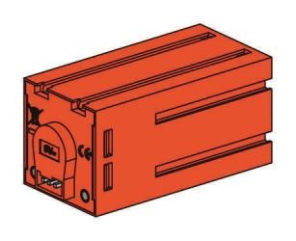The high-bay rack feeder is powered by three encoder motors. This is possible through permanent magnet DC motors, which enable the incremental measurement of angles with the help of Hall effect sensors. The encoder motors have a rated voltage of 24 V and a maximum output of 2.03 W at 214 rpm. The current input at maximum power is 320 mA. The integrated gearbox gear ratio is 25:1. This means that the encoder produces three pulses per motor shaft rotation or 75 pulses per rotation of the gearbox output shaft. Since two phase shifted pulses are indexed, the encoder is able to distinguish the direction in which the motor is rotating.

The connection is made via a four core cable with a red wire for the 24 V output and a green wire for the ground connection. The black and yellow wires transmit the pulse (push-pull output, 1 kHz max., 10 mA max.).

**Phototransistor:**

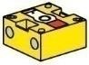Phototransistors are used as light barriers for the automated high-bay warehouse. In the process, the phototransistor conducts electricity from a certain level of brightness. However, if this luminescence threshold is exceeded, the phototransistor loses its conductivity. Together with a lens tip lamp, which faces the phototransistor, the phototransistor usually conducts electricity and can thus be used as a light barrier. A stray light hood can be used to reduce the effects of ambient light.

Caution: When connecting the phototransistor to the power supply, pay particular attention to correct polarity. Connect the positive pole at the red marking on the phototransistor.

**Mini-switch:**

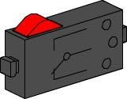Mini-switches are used as reference switches for the vacuum gripper robot. When using incremental measuring methods, a reference switch is used to determine the absolute position or absolute angle. The miniswitch used in this case can be used both as a normally closed contact and as a normally open contact. When the switch is actuated, equipotential bonding occurs between contact 1 and contact 3, while the connection between contact 1 and contact 2 is separated. Figure 1 shows the schematic circuit diagram of the mini-switch.

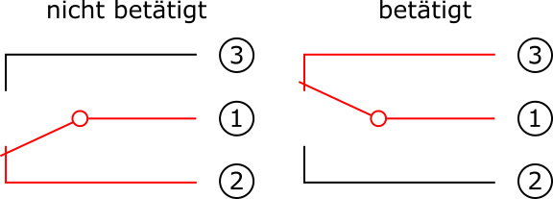

not pushed

pushed

Fig. 1: Mini-switch circuit diagram

**S motor 24V:**

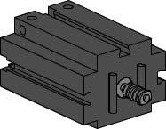The high-bay rack feeder boom is powered by an S motor. This compact motor is a permanent magnet DC motor that can be used together with an attachable motor reducing gearbox. The motor is operated at a rated voltage of 24V DC and the maximum current input is 300 mA. The result is a maximum torque of 5 mNm and an idling speed of 10.700 rpm. The motor reducing gearbox has a gear ratio of 64.8:1 and a lateral output.

**IR trail sensor:**

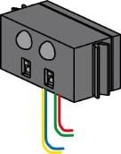The IR trail sensoris a digital infrared sensor for the identification of a black trail on a white background at a distance of five to 30 mm. It consists of two transmission and two receiver elements. The signals are output as push-pull outputs. The connection is made using four cables. The red cable must be connected to the 9V DC and the green cable must be connected to ground. The black and yellow cables transmit the signals. The adapter board converts the voltage and adjusts the level from 24V DC to 9V DC.

**What is a high-bay warehouse?**

A high-bay warehouse is a space-saving storage area for storing and retrieving goods. In most cases high-bay warehouses are designed as pallet rack storage systems. This standardization provides for a high level of automation and connection to an ERP (Enterprise Resource Planning) system. High-bay warehouses are characterized by superior space utilization and high initial capital costs.

Storing and retrieving goods is handled by rack feeders that move in a lane between two rows of racks. This area is part of the receiving station, where identification of goods also takes place. Using conveyor systems, such as chain, roller or vertical conveyors, the goods arrive and are transferred to the rack feeders. If the rack feeders are automated, no one is allowed to enter this area. In the case of the automated high-bay warehouse, the goods are provided on a conveyor belt. The goods are identified by a barcode, which is ready by the trail sensor.

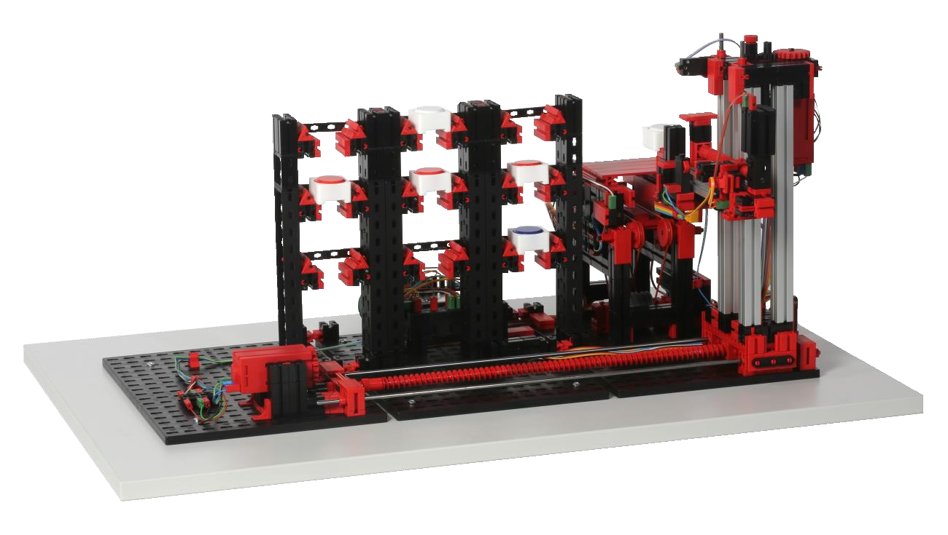

High

-

bay rack feeder

Conveyor system

with

identification

High

-

bay storage rack

Fig. 1: High-bay warehouse areas

Goods are frequently stored based on the dynamic warehousing principle. There is no fixed arrangement between storage position and goods, so the goods to be stored are placed in any free spot. This promises path efficiency. The warehouse management system saves the position of the stored goods, making them available. A (partly) automated identification of goods, which is usually done using FRID chips or barcodes at a central location called the identification site, and standardization of storage areas (same external dimensions, same permitted unit weights) are indispensable. The ABC strategy in which the warehouse is divided into three zones at varying distances from the storage/retrieval area, is used to further streamline the pathways. Frequently required goods are placed in the A zone, which is directly next to the storage/retrieval area. Rarely needed goods are correspondingly stored in the C zone, which is far away from the storage/retrieval area.

In the case of the automated high-bay warehouse, it is possible to visually demonstrate static and dynamic warehousing. In the case of static warehousing, for instance, each row is assigned a color.

For instance, the top row is assigned the color white, the middle row is assigned red and the bottom row is assigned blue. The individual colored rows are filled from the position closest to the preloading zone to the position farthest away from the pre-loading zone. In the case of dynamic storage, there is no fixed assignment between rack row and color. This results in the high-bay rack feeder storing the workpiece in any spot available. The assignment between color and selected storage position has to be saved by the warehouse management system.

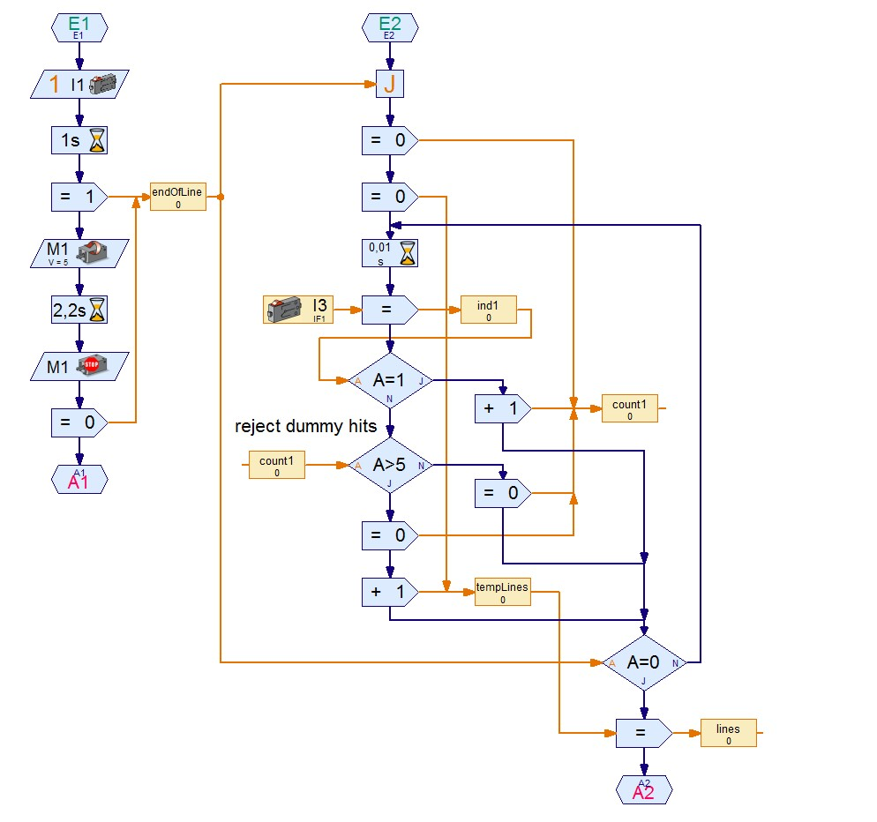

Fig. 2: Algorithm for barcode recognition in ROBOPro

The workpiece is identified by the automated high-bay warehouse using a simple barcode. The workpiece carriers have a code on them, which is assigned the color white, red or blue. This code is analyzed by a trail sensor. The trail sensor registers the differences in light and dark and interprets these either as a mark or as a reflection depending on the width. Reflections occur frequently on the edges of workpiece carriers and need to be dismissed in order to prevent false interpretations. The difference is detected as a result of the width of the dark areas or the number of sequential time increments that are interpreted as dark. The dark areas with more than five sequential time increments are considered a mark. Figure 2 shows how this algorithm is implemented for barcode detection in ROBOPro. This thus defined minimum width limits the number of patterns to be distinguished which can be used to identify the workpiece, but it is sufficient for coding the three colors.

  

|  |  |  |
| --- | --- | --- |
| White | Red  Fig. 3: Color codes | Blue |

Figure 3 shows the assignment between the codes used and the respective colors. These marks are applied to the workpiece carrier side facing the trail sensor, thus allowing assignment of a workpiece carrier to a colored workpiece.

**Calibration**

The positions traveled by the automated high-bay warehouse feeder are stored in the “Calibration” subroutine. The positions describe the location of the high-bay storage rack slots and the location of the conveyor belt relative to the zero position of the feeder. Only the X and Y positions that are reached using the encoder motors are taken into account. The Z positions that are reached with an S motor are reached with the help of push-button switches and therefore do not need to be calibrated. The ten positions (new storage locations + conveyor belt) are described with the help of eight variables. For the storage locations, the levels (three X positions) and rack rows (three Y positions) are stored as variables. In the case of the conveyor belt, the X and Y positions are also stored.

Table 1: Predefined and modified positions of the high-bay warehouse

|  |  |  |  |
| --- | --- | --- | --- |
| **Position** | **Variable name** | **Predefined value** | **Adjusted value** |
| Conveyor belt (X position) | X_0 | 10 |  |
| Conveyor belt (Y position) | Y_0 | 729 |  |
| First row | X_1 | 760 |  |
| Second row | X_2 | 1365 |  |
| Third row | X_3 | 1972 |  |
| Top level | Y_1 | 85 |  |
| Middle level | Y_2 | 460 |  |
| Bottom level | Y_3 | 850 |  |